**Model Development Phase Template**

|  |  |
| --- | --- |
| Date | 15 March 2024 |
| Team ID | 740012 |
| Project Title | **Predicting IMF-Based Exchange Rates: Leveraging Economic Indicators for Accurate Regression Modeling** |
| Maximum Marks | 4 Marks |

**Initial Model Training Code, Model Validation and Evaluation Report**

The initial model training code will be showcased in the future through a screenshot. The model validation and evaluation report will include classification reports, accuracy, and confusion matrices for multiple models, presented through respective screenshots.

**Initial Model Training Code:**



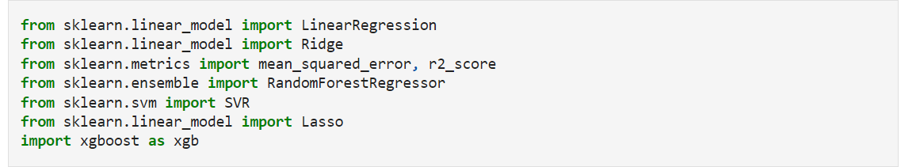

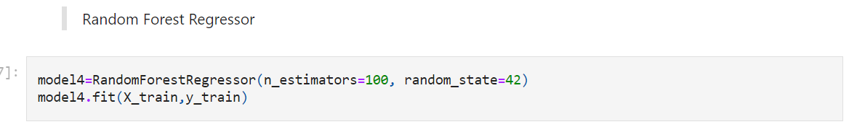

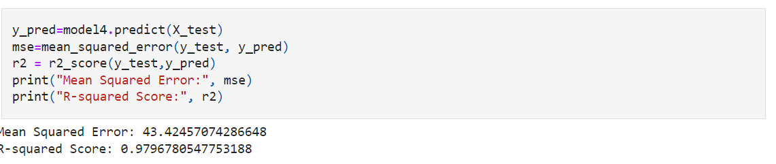

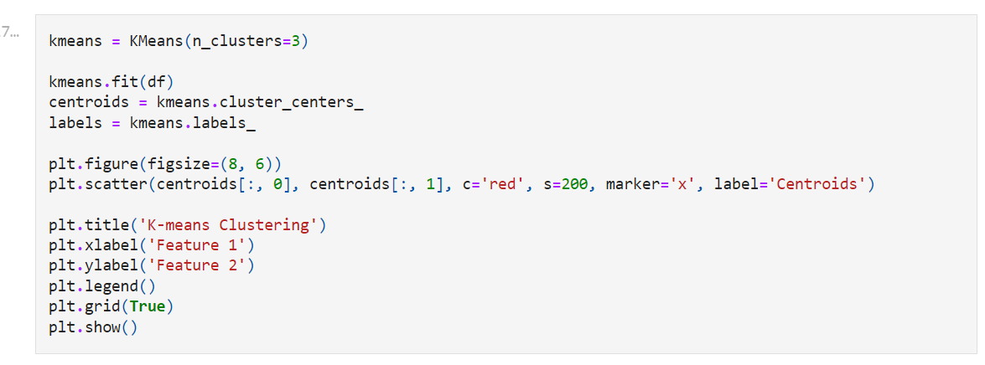

**Model Validation and Evaluation Report**

|  |  |  |
| --- | --- | --- |
| Logistic Regression Model |  | |
| Random forest Model |  |
| Decision Tree Model |  |
|  |  |
| Gradient Boosting |  |